UGA: Ecology
to request a delegate
for EMPLOYEE Travel Authorizations, Travel Reimbursements and Non-Travel Reimbursements
(set up required once unless there is a turnover in Ecology staff)

The system only allows you to request someone to serve as a delegate on your behalf. Feel free to reach out to your EBO contact for help, if needed.
- Within UGA Financial Management, click the TE Profile & Delegation tile.
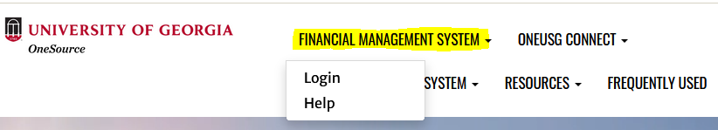

- On the Authorize Users page, click the + sign to add a new row.
- In this new row, within the Authorized User ID field, enter the MyID of the employee(s) to which you wish to delegate authority.
  - There are times when one or several staff members are out of the office, even at the same time. In order to provide you with the most continuous support we request that you add each of the following:
    - Amberly Tankersley (MyID: ak34528)
    - Laura Leachman (MyID: ll54883)
    - Jennifer Mathews (MyID: jtm)
    - Mica Turner (MyID: mturner)
- Under Expense Document Type, select Travel Authorization.
- Under Authorization Level, select Edit & Submit.
- Click the + sign to add a new row again.
- In this new row, within the Authorized User ID field, enter the MyID of the employee(s) to which you wish to delegate authority.
  - There are times when one or several staff members are out of the office, even at the same time. In order to provide you with the most continuous support we request that you add each of the following:
    - Amberly Tankersley (MyID: ak34528)
    - Laura Leachman (MyID: ll54883)
    - Jennifer Mathews (MyID: jtm)
    - Mica Turner (MyID: mturner)
- Under Expense Document Type, select Expense Report.
- Under Authorization Level, select Edit.
- Click the Save button to save your delegate selections.

